

Master Degree in Computer Science

[Laboratory of Applied Robotics](http://disi.unitn.it/~palopoli/courses/ECL/ECL.html)

Control design for the motor

Digital Implementation of controller

Deliverable 2

Antonio Sciarretta, Davide Todeschi, Elena Tumanov

December 24, 2015

1. General description

Control Design and Digital implementation of controller for the Lego NXT motor.

Deliverable 2 goal is to show our designed controller, describe it properties and digital implementation.

* 1. General information about Control design for the motor

**Root locus:** In control theory and stability theory, root locus analysis is a graphical method for examining how the roots of a system change with variation of a certain system parameter, commonly a gain within a feedback system. This is a technique used as a stability criterion in the field of control systems developed by Walter R. Evans which can determine stability of the system. The root locus plots the poles of the closed loop transfer function in the complex S plane as a function of a gain parameter (see pole–zero plot). [1]

**Closed-loop transfer function:** in control theory is a mathematical expression (algorithm) describing the net result of the effects of a closed (feedback) loop on the input signal to the circuits enclosed by the loop. [2]

In such a case, we have the plant P(s) and an additional block C(s): the controller. The objective was to determine C(s) in order to satisfy certain closed loop performance.

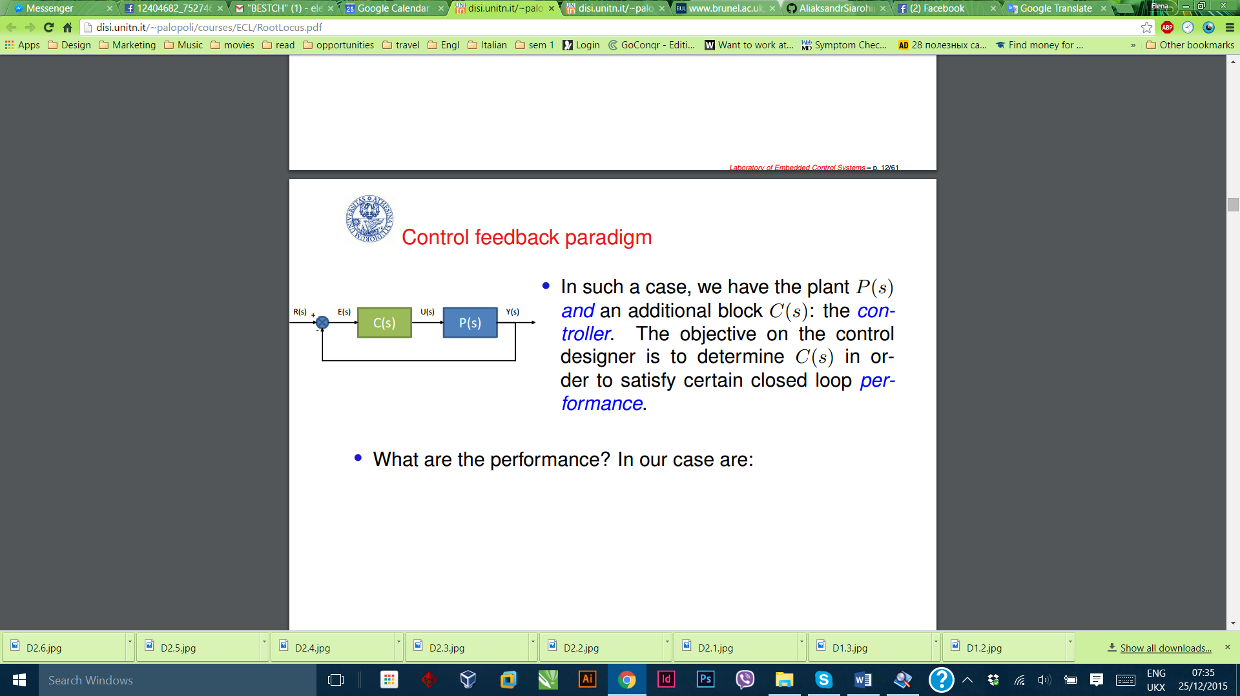

Fig.1 Closed loop [3]

1. Control design for the motor
   1. Needed performance

Steady state tracking error = 0;

Settling time < 0.2s;

Maximum overshoot < 20%;

Rise time.

* + 1. Closed loop system

1. Closed loop system:

Gcl = Kc*C*G /(1 + Kc*C*G);

1. Set Kc = 1 and C = 1;
2. Added a pole C = 1/s – to obtain 0 steady state error, possible because of Internal model principle.
   1. Our Design

Controller:

C = (s + 16) * (s + 16)/(s*(s+31));

Kc = 12.

Root locus is illustrated in ﬁg. 2, and the response to the step function in ﬁg. 3.

Results from Scicoslab simulation fig.4 are shown in the following ﬁgures:

• Speed (ω) in ﬁg. 5

• Power in ﬁg. 6

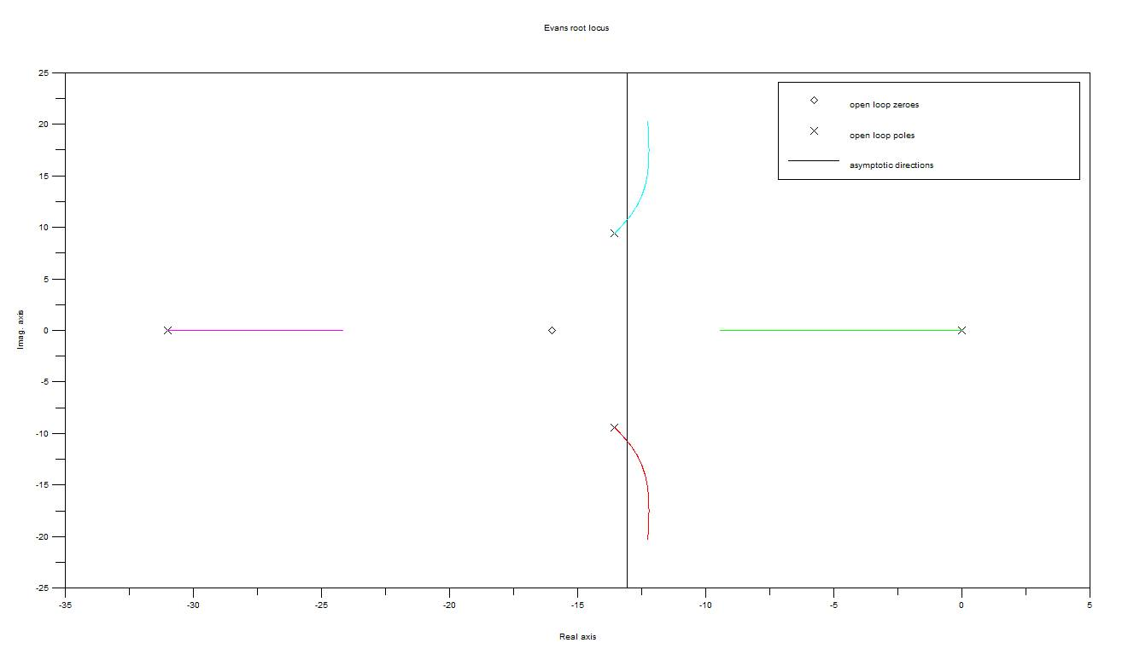

Fig.2 Root locus

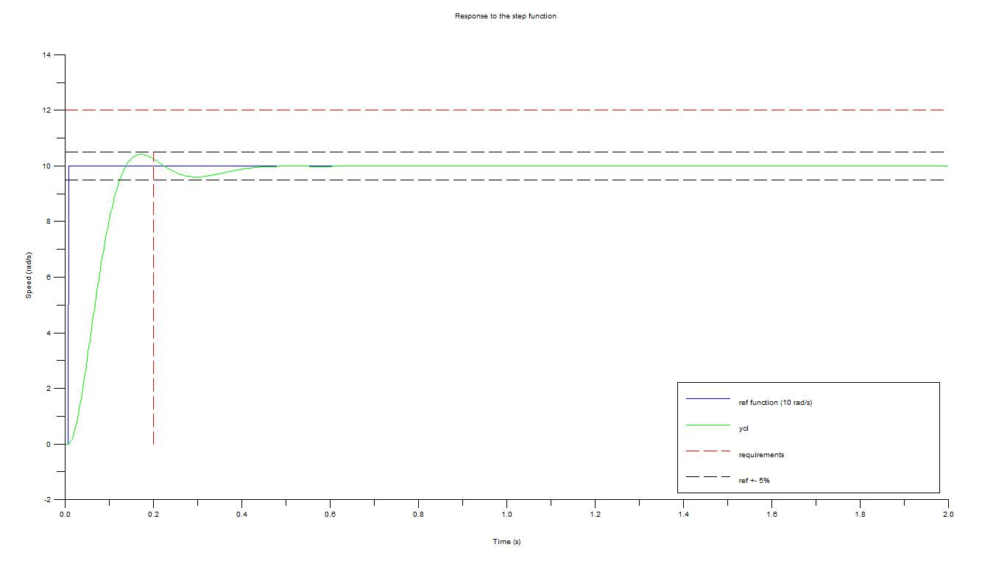

Fig.3 Response to the step function

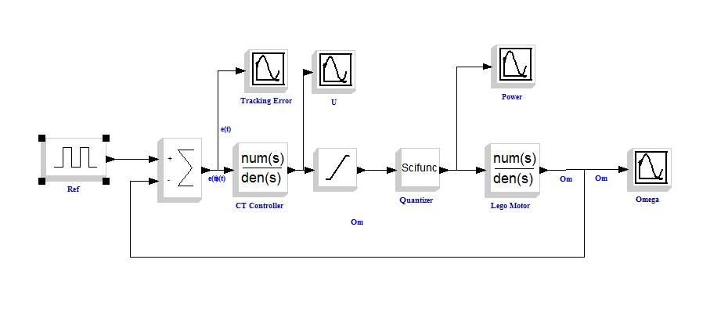

Fig.4 Controller Design

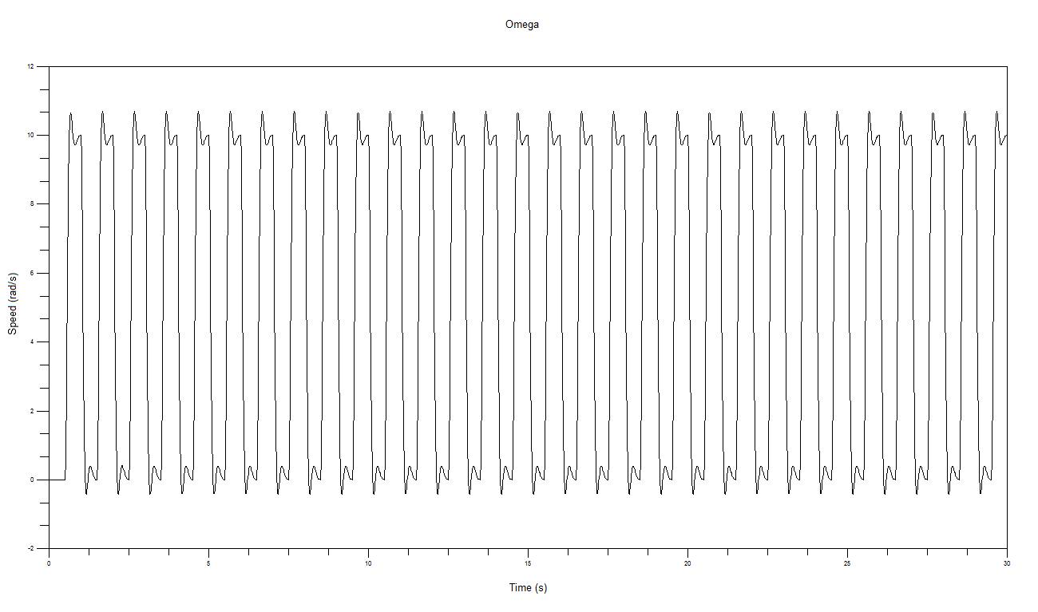

Fig.5 Speed (ω)

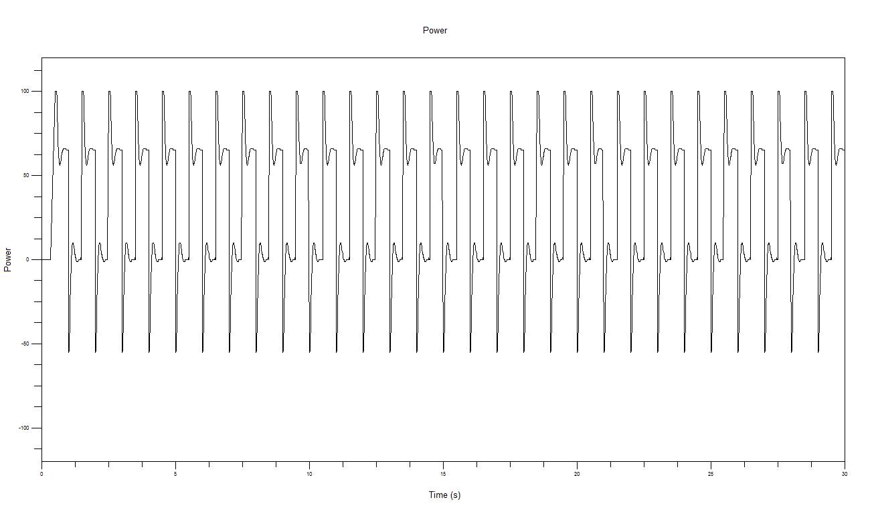

Fig.6 Power

1. Digital implementation of the controller

What we have done fig.7:

Set a speed we want to reach (REF)

Evaluated the current speed (SPE)

Calculated the power we need (POW)

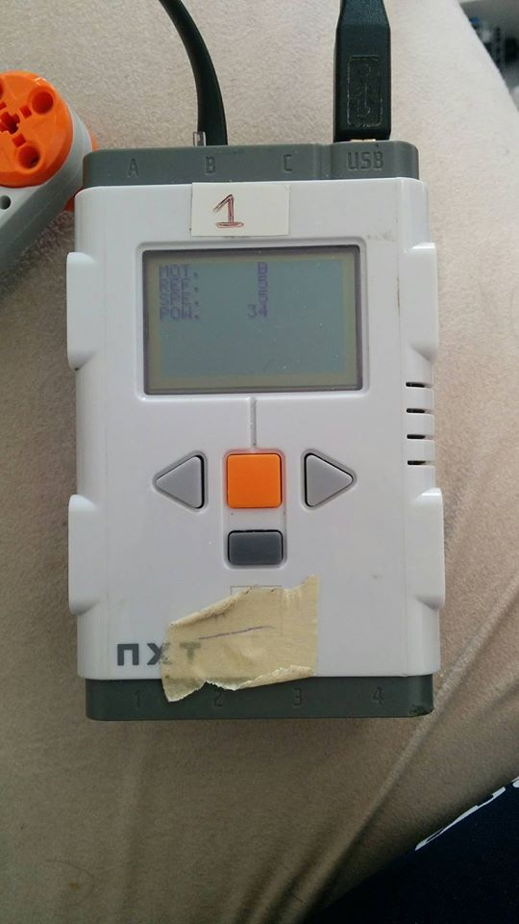

Fig.7 Brick with REF, SPE and POW values

Digital version of controller obtained using trapezoid rule:

Kc * (s + 16) * (s + 16)/(s*(s+31)) = y(s)/u(s)

Kc * ((2/T * (q-1)/(q+1)) + 16) * ((2/T * (q-1)/(q+1)) + 16)/(( 2/T * (q-1)/(q+1))*(( 2/T * (q-1)/(q+1))+31)) = y(2/T * (q-1)/(q+1))/u(2/T * (q-1)/(q+1))

y(k+2) = 1 / (-31*T - 2) * (-4*y * (k+1) - (31*T - 2) * y(k) + gain * (u * (k+2) * (-128 * T^2 – 32 * T - 2) + u * (k+1) * (4 – 256* T^2) - u(k) * (-128*T^2 + 32 * T-2)))

1. Conclusion

Our scope was to control design for the motor and to realize digital implementation of controller. Above we demonstrated our method of digital implementation using trapezoid rule.

References:

[1] https://en.wikipedia.org/wiki/Root_locus

[2] https://en.wikipedia.org/wiki/Closed-loop_transfer_function

[3] <http://disi.unitn.it/~palopoli/courses/ECL/RootLocus.pdf>